#### Why Digital Water Flow Meter?



Water flow meters are very important devices and often used in daily life and manufacturing. As its technology, water flow meters have mechanical type and electronic type. [Digital water flow meters](https://www.abestmeter.com/) have no standard or official definition. But as usual understanding, it should at least have two features:

1).Digital display screen. This is different from traditional mechanical type water flow meters. Traditional flow meters are usually equipped with dial indicating reading, which is not convenient to read.

2).No moving parts. In the past, mechanical water meters are sensing water flow by moving parts, e.g. paddle wheel, etc. This design brings many disadvantages, e.g. short life, poor stability in long term, narrow wide flow range, easily blocked by materials in water, etc. Later as electronic technology development, many electronic digital water flow meters are released. Comparing with mechanical type flow meters, they have many advantages: higher accuracy, no moving parts, no pressure loss, long-term stability, versatile signal output, wide flow velocity range, etc.

**4 Type Electronic Water Flow Meters**

From the two rules above, main selling electronic water flow meters  have ultrasonic, electromagnetic, vortex, mass, etc on market. Except these types listed, there are also other types for niche requirement,but they are not main items, so don't introduce them.

1.Ultrasonic Flow Meter-Recommendation for Water Flow

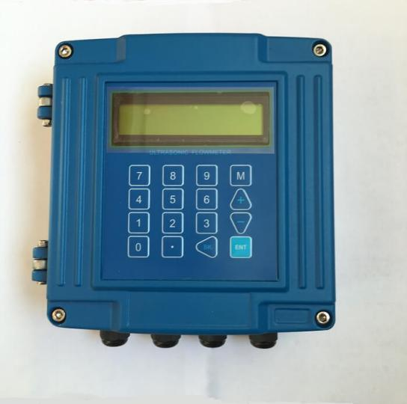

Ultrasonic water flow meter has been one of the main selling items in the area and it has 3 kinds of structures: clamp on, insertion and inline, which can almost meet more the requirement of water flow measurement. Meanwhile, ultrasonic flow meters can support low power consumption, and this feature makes it more reliable to provide battery powered measurement without external DC/AC power supply. This is very useful for many applications where external power is not easy to get.

2.Electromagnetic Flow Meter-Recommendation for Water Flow

Magnetic flow meters are one of the main selling product for water flow test. It mainly has two structures: insertion and inline type. The inline type are main selling models which features high accuracy. The typical accuracy is 0.5 and max accuracy can reach 0.3-0.2. It can support battery powered measurement, but its power consumption is bigger than ultrasonic flow, especially when pipe size is bigger, its power consumption is much larger. Thus, when battery power supply, its max pipe size is often limited to DN300mm.

3.Vortex Flow Meters-Not Recommendation for Water Flow

Vortex flow meters can be used for gas and liquid. So it can be used for liquid, water is no exceptional. But it is not often used for water. Comparing with ultrasonic and magnetic flow, its price is not lower and its technology is not so stable like them. So vortex flow meter is more often used for gas. The performance of Vortex flow meter is easily influenced by vibration.

4.Mass Flow Meters-Not Recommendation for Water Flow

Mass flow meters mainly have 2 kinds: thermal mass flow meter and Coriolis mass flow meter. Thermal mass flow meter can be used for liquid and water, but it is mainly used for gas flow measurement. Mass flow meter has a very high accuracy and can be used for water flow measurement. But mass flow meter is very expensive, so it is not necessary for water flow except project has precise requirement. So for most of applications, mass flow meter is not the first consideration for water flow.

**Caution:Misleading Advertising of Electronic Flow Meter**



Many companies have made a misleading advertisement to announce their flow meters are electronic water flow meters, but in fact the truth is not so. They just add a display unit to their mechanical water meters and mechanical flow meters. This is not real electronic flow meter and their core flow sensing part still has moving parts.

Thus, when you want to purchase flow device for your project, you should firstly check whether it is real digital electronic flow meters. The judging rule is very simple and just check whether the sensing part is mechanical type with moving parts.

The warm tip is that the first consideration is to select electronic flow meter when you have a requirement. Because false electronic flow meter will improve its cost after some time using, and you won't get benefit from real advanced electronic flow meter.

From：https://www.abestmeter.com/digital-electronic-water-flow-meter/